Assignment 11

Question 1 = Write a query that uses a subquery to obtain all orders for the customer named Cisneros. Assume you do not know his customer number (cnum).

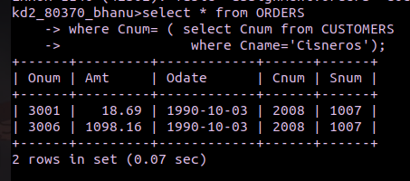

Question 2 = Write a query that produces the names and ratings of all customers who have above-average orders.

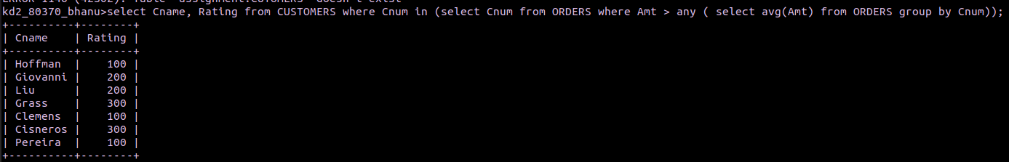
Question 3. Write a query that selects the total amount in orders for each salesperson for whom this total is greater than the amount of the largest order in the table

